**St. Francis Institute of Technology, Mumbai-400 103**

**Department of Information Technology**

**A.Y. 2024-2025**

**Class: TE-ITA/B, Semester: VI**

**Subject: MAD & PWA LAB**

**Experiment – 7: Testing and deploying production ready Flutter App on Android platform.**

1. Aim: To test and deploy production ready Flutter App on Android platform. 2. Objectives: After study of this experiment, the student will be able to

● Test a production ready Flutter App.

● Deploy the Flutter App on Android/iOS phone.

3. Outcomes: After study of this experiment, the student will be able to

● Analyze and Build production ready Flutter App by incorporating backend services and deploying on Android/iOS

4. Prerequisite: Dart Programming Language.

5. Requirements: Android Studio, Flutter framework, Internet Connection, mobile PC suite software, USB data cable.

6. Pre-Experiment Exercise:

Brief Theory:

Testing mobile application

Testing is one of the most important phases of mobile app development. You can’t build a high-quality app without testing it. The Flutter framework provides comprehensive support for Flutter automated testing of mobile apps. Automated tests help to ensure that your app performs correctly before you publish it while retaining your features and bug fix velocity.

Categories of automated testing:

● A unit test tests a single function, method, or class.

● A widget test (in other UI frameworks referred to as component test) tests a single widget.

● An integration test tests a complete app or a large part of an app.

Deploying the mobile app on a mobile device

Steps to run mobile app on a real device:

1. Install mobile PC suite software on the computer.

2. Enable USB debugging mode in Android device.

3. Connect the mobile device via USB data cable to the computer.

4. Go to the IDE and select the real device to run Flutter App.

5. Click on ‘Run’ to run the App.

7. Laboratory Exercise

A. Program

1. Write 4-5 test cases for your mobile application.

2. Deploy and run the app on your mobile phone.

B. Result/Observation

1. Print out of program code and output.

8. Post-Experimental Exercise

A. Questions:

1. Describe the steps to publish a flutter mobile application.

B. Conclusion:

1. Write what you have learnt in the experiment.

C. References:

1. https://docs.flutter.dev/testing

2. https://flutteragency.com/how-to-run-test-flutter-app-on-a-real-device/ 3. Beginning App Development with Flutter: Create Cross-Platform Mobile Apps, By Rap Payne, 2019.

**Laboratory Exercise:**

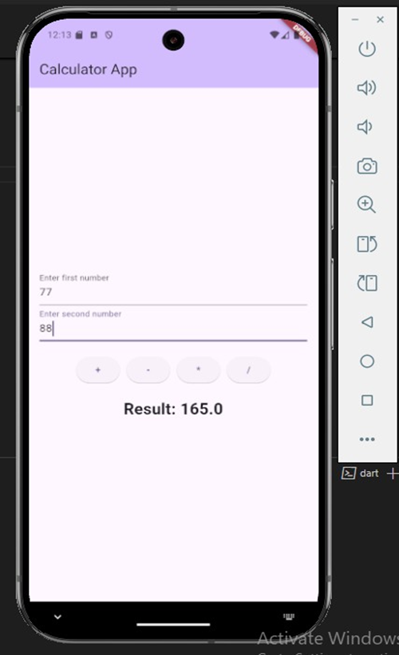

Pairing the device with my phone:

Steps:

1.enable developer mode on android phone:

a)Go to settings>aboutphone>Softwareinformation>buildnumber(tap 7 times)

b)Go back to settings and scroll down: Developer options>enable wirelessdebugging

Ensure that pc and phone are connected on same wifi.

c)tap on wireless debugging>pair device. And run below commands on pc.

1)adb pair:

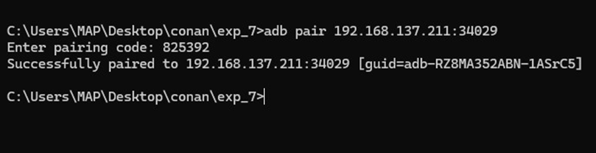

2)adb connect:

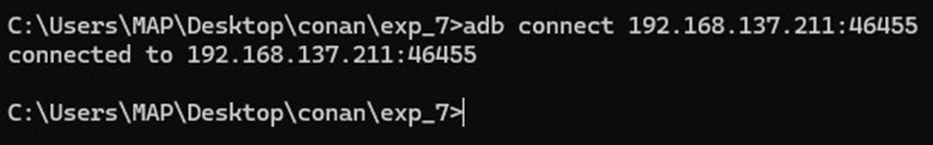

3)adb devices

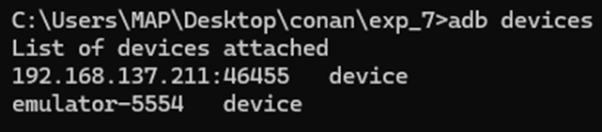

4)flutter run>[1](select your mobile device number):

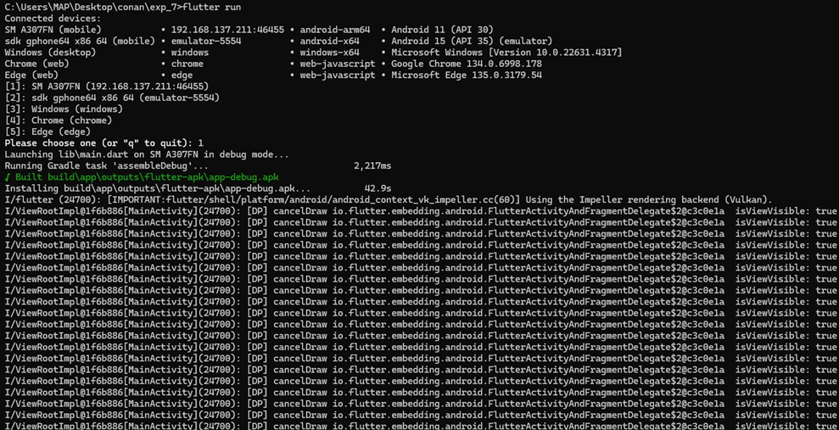

Output on Phone:

